#### Project Report On

**“Online Library Management System”**



##### Submitted By: Guided By

1. Bhupendra Mr.Vijay Gupta
2. Shraddha Panwar Assistant Professor
3. Vijay Vaishnav IIIM, Jaipur.

##### Team Number:-

**ACKNOWLEDGEMENT**

The satisfaction that accompanies that the successful completion of any task would be incomplete without the mention of people whose ceaseless cooperation made it possible, whose constant guidance and encouragement crown all efforts with success.

We are grateful to our project guide Mr.Vijay Gupta for the guidance, inspiration and constructive suggestions that helpful us in the preparation of this project.

We also thank our colleagues who have helped in successful completion of the project.

Bhupendra Singh Baghela Shraddha Panwar

Vijay Vaishnav

# CERTIFICATE

This is to certify that this report of Attendance Management System embodies the original work done by **Bhupendra Singh Baghela, Shraddha Panwar, Vijay Vaishnav** during this project submission as a partial fulfillment of the requirement for the System Design Project of Masters of Computer Application IV Semester, of the Rajasthan Technical University, Kota.

Swati V. Chande Principal

(MCA Department) International School of Informatics and Management

Mr.Vijay Gupta International School of Informatics and Management

Table of Contents

* 1. Synopsis 5
  2. Feasibility Study 9
  3. Data Tables 11
  4. Data Flow Diagrams 14
  5. Entity Relationship Diagram 15
  6. Screen Shots Of Form 17
  7. Future Scope 22
  8. Conclusion 24
  9. Bibliography 25



## Online Library Management System

#### Introduction:-

* 1. **Purpose:-**

The purpose of this application are as follows :

* + - The software is for automation of library.
    - It provides following facilities to

Operator :

* + - Can enter details related to a particular book.
    - Can provide membership to members.

Admin :

* + - Can read and write information about any member.
    - Can update, create, delete the record of membership as per requirement and implementation plants.

2.) Scope :

The different areas where we can use this application

are :

* Any education institute can make use of it for providing information about author, content of the available books.
* It can be used in offices and modifications can be easily done according to requirements.

3.) Technology Used :

Front End : Servlets, HTML, Java script.

Back End : MS Access, Apache Tomcat server.

4.) Assumptions

* + This application is used to convert the manual application to the online application.
  + Customized data will be used in this application.
  + User does not have right to enter information about books.

5.) Overview :

Project is related to library management which provides reading services to its members. Any person can become a member of the library by filling a prescribed form.

They can get the book issued, so that they cab take home and return them.

6.) Functionality :

* Online membership.
* Keeps the track of issues and submission of books .

**Feasibility Study**

In feasibility study phase we had undergone through various steps which are describe as under :

1. Identify the origin of the information at different level.
2. Identify the expectation of user from computerized system.
3. Analyze the draw back of existing system (manual) system.

#### WORKING OF PRESENT MANUAL SYSTEM

The staffs of library are involved in the following tasks.

1. Membership process : person have to fill membership form and they are provided with member id.

#### DRAWBACKS OF PRESENT SYSTEM

Some of the problems being faced in manual system are as follows:

* 1. Fast report generation is not possible.
  2. Tracing a book is difficult.
  3. Information about issue/return of the books are not properly maintained.
  4. No central database can be created as information is not available in database.

#### PROPOSED SYSTEM

There will be three major components :

1. Stock maintenance.
2. Transaction entry.
3. Reports.

Proposed system provides with following solutions :

1. It provides "better and efficient" service to members.
2. Reduce the workload of employee.
3. Faster retrieval of information about the desired book.
4. Provide facility for proper monitoring reduce paper work and provide data security.
5. All details will be available on a click.

Data Tables:

Table : Members

|  |  |  |  |  |
| --- | --- | --- | --- | --- |
| S.no. | Coloum Name | Data Type | Length | Description |
| 1 | Id_no | Text | 50 | Unique identification of the members |
| 2 | Name | Text | 70 | Name of members |
| 3 | Address | Text | 100 | Location of Members |
| 4 | Date of Issue | Date/Time |  | Date of Registration |
| 5 | Date of Expiry | Date/Time |  | Registration expiry date |
| 6 | Status | Text | 50 | Permanent/Temporary |

Table : Add Books

|  |  |  |  |
| --- | --- | --- | --- |
| s.no. | Column Name | Date- Type | Description |
| 1 | Book_name | Text | Title of the book |
| 2 | Book_code | Text | Book identification number |
| 3 | Author | Text | Author of books |
| 4 | Date of arrival | Date/time | Date on which book was received |
| 5 | Price | Text | Cost of books |
| 6 | Rack_no | Text | Almirah no |
| 7 | No_of_books | Text | Quantity of books |
| 8 | Subject_code | Text | Unique identification no of particular subject |

Table: issue

|  |  |  |  |
| --- | --- | --- | --- |
| s.no. | Column Type | Date Type | Description |
| 1 | Id_no | Text | User identification number |
| 2 | Book_name | Text | Title of books |
| 3 | Issue_date | Date/time | Date on which book is issued |
| 4 | Due_date | Date/time | Due date on which book is to be returned |

Data Flow Diagram (DFD)

Student

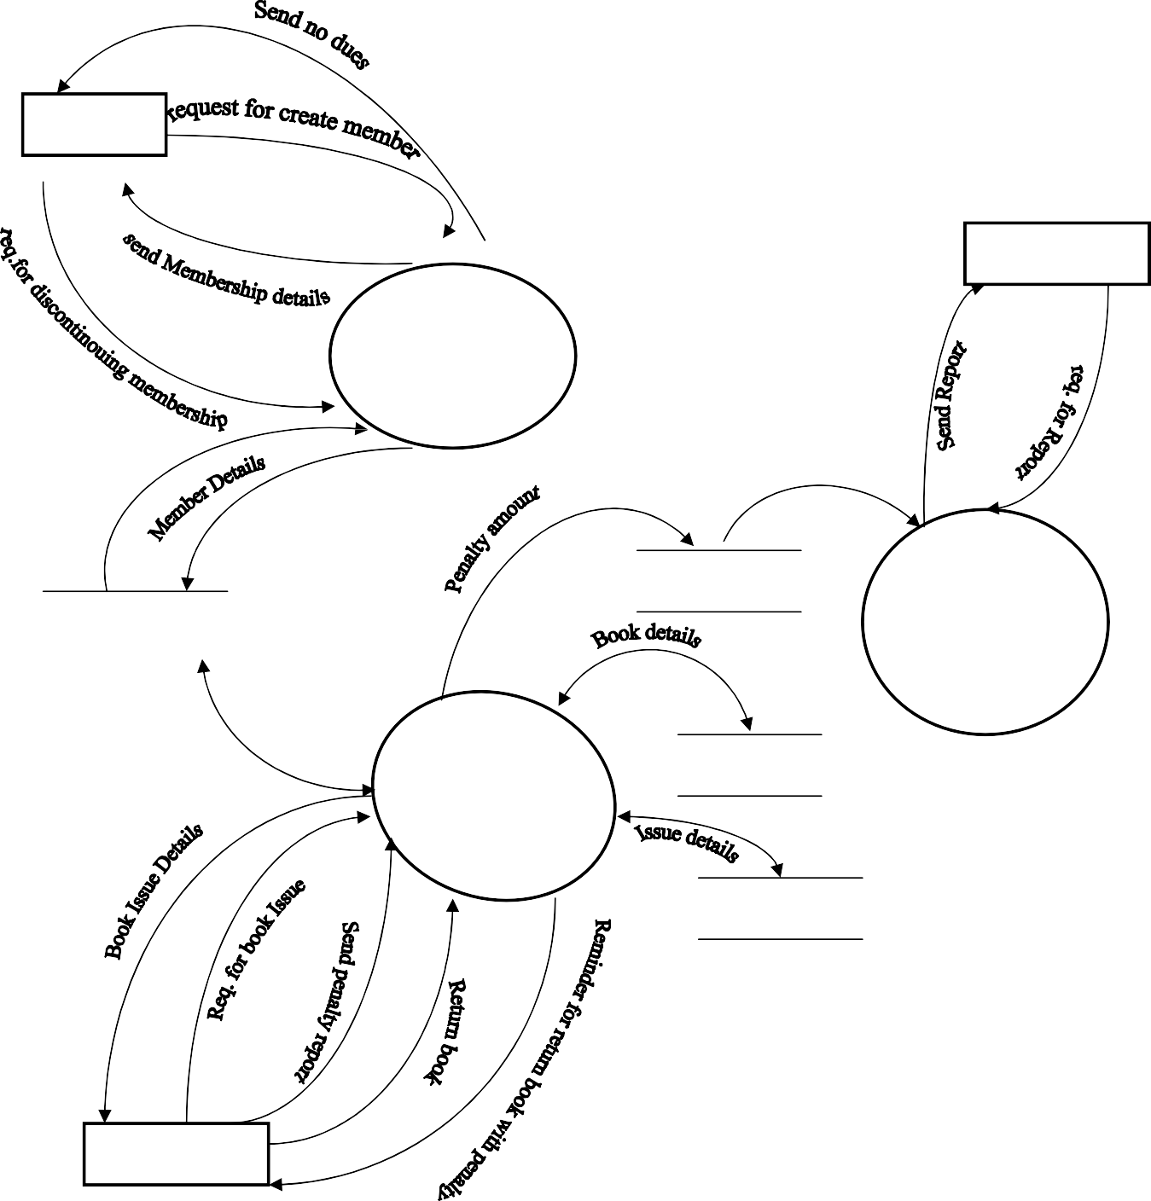

Manageme

Membershi p Manageme

Member

Penalty

Report manageme nt

Book Issue Manageme nt

Books

Book Issue

Student 14

**E-R DIGRAM**

It is clear that the physical objects from the previous section

– the member, books, library – correspond to entities in the Entity-Relationship model, and the operations to be done on those entities – holds, checkouts, and so on – correspond to relationships. However, a good design will minimize redundancy and attempt to store all the required information in as small a space as possible.

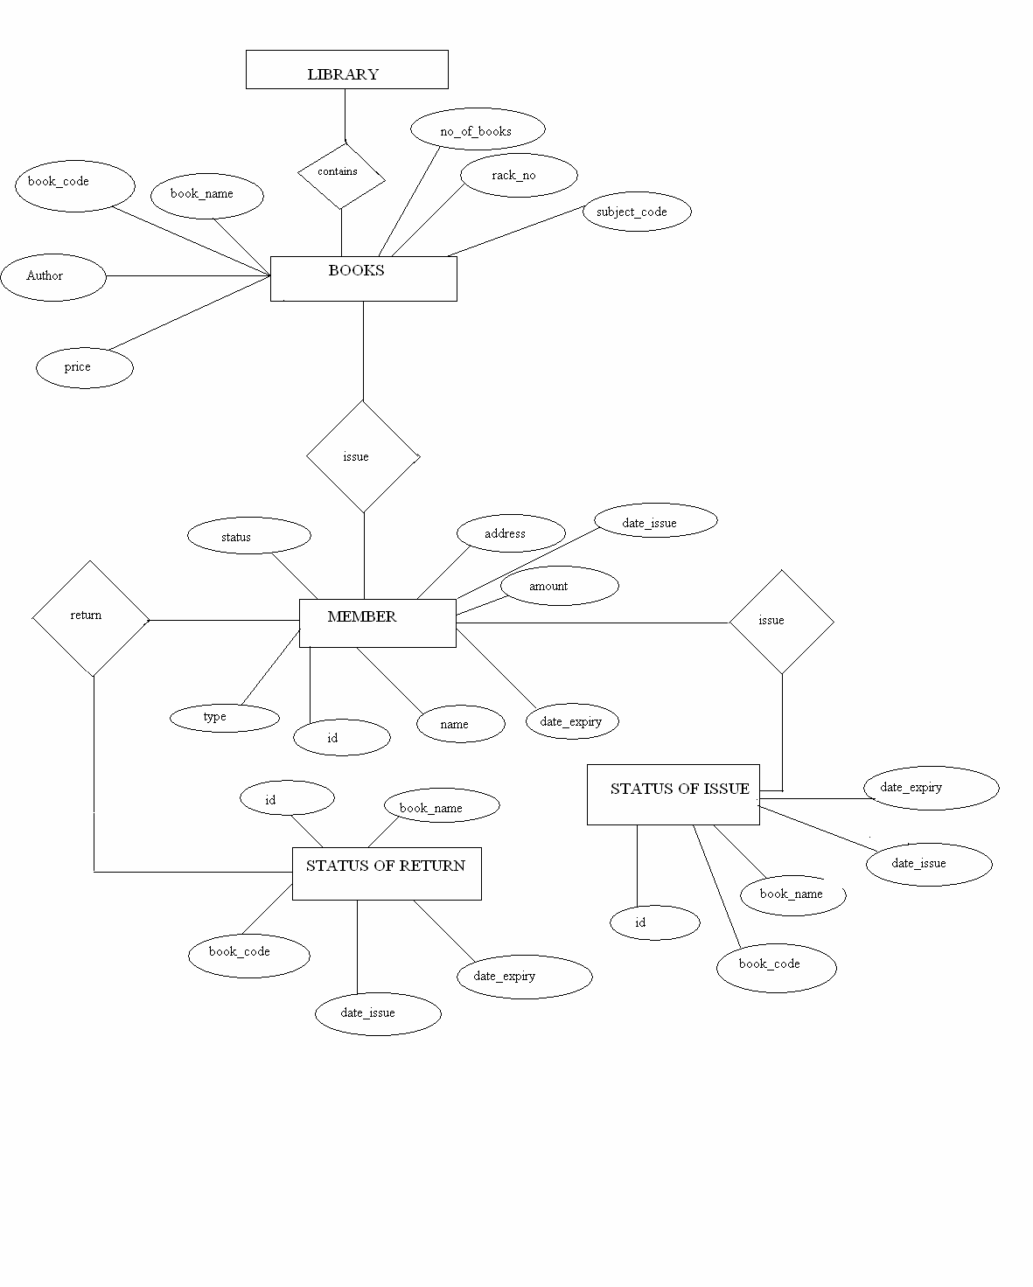

### SNAPSHOTS

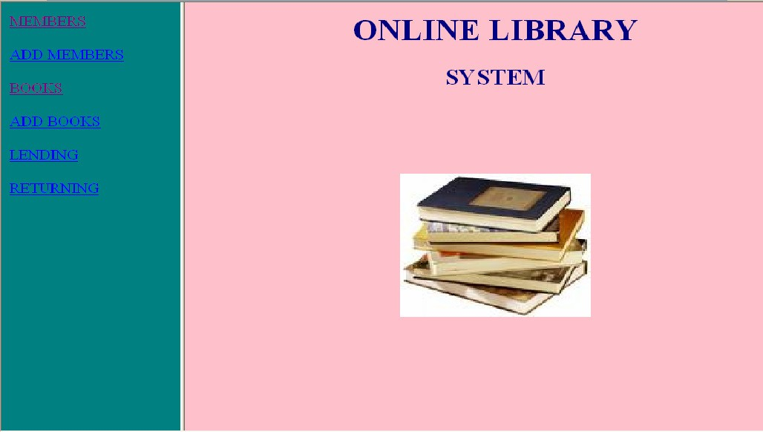

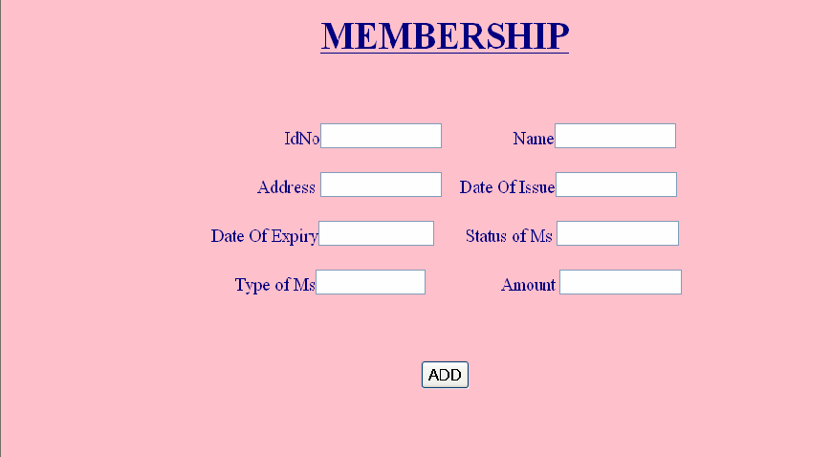

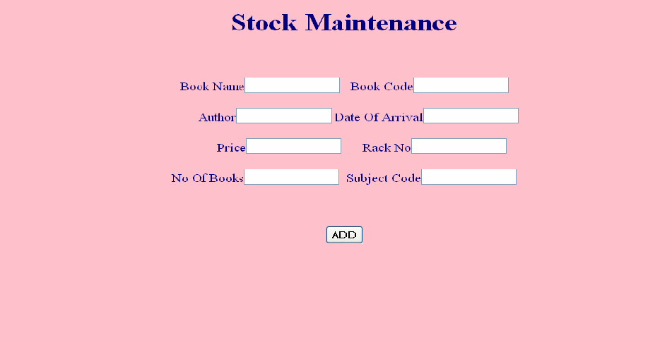

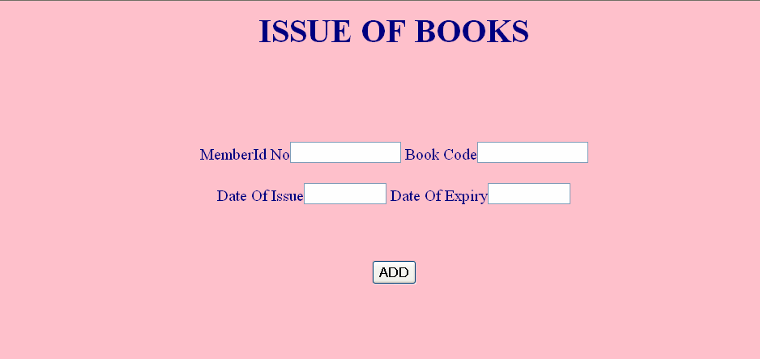

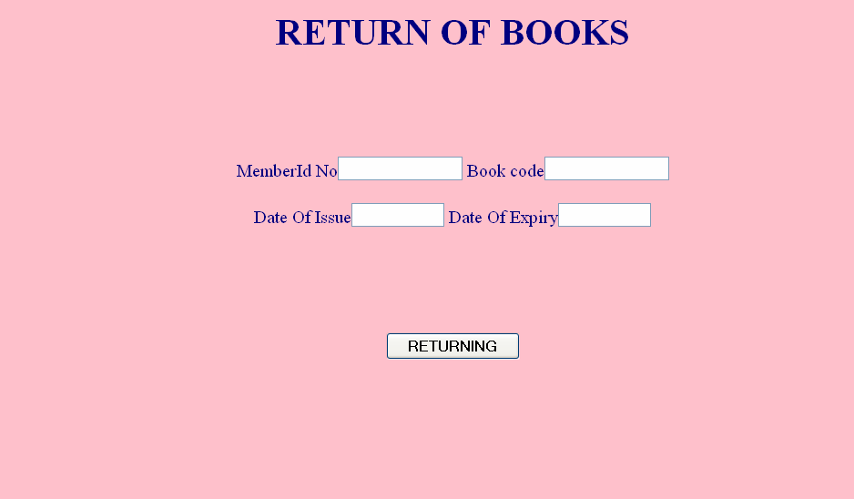

**Future Scope**

##### FUTURE SCOPE OF APPLICATION :

This application can be easily implemented under various situations. We can add new features as and when we require. Reusability is possible as and when require in this application. There is flexibility in all the modules.

##### SOFTWARE SCOPE:

* **Extensibility**: This software is extendable in ways that its original developers may not expect. The following principles enhances extensibility like hide data structure, avoid traversing multiple links or methods, avoid case statements on object type and distinguish public and private operations.
* **Reusability**: Reusability is possible as and when require in this application. We can update it next version. Reusable software reduces design, coding and testing cost by amortizing effort over several designs. Reducing the amount of code also simplifies understanding, which increases the likelihood that the code is correct. We follow up both types of reusability: Sharing of newly written code within a project and reuse of previously written code on new projects.
* **Understandability:** A method is understandable if someone other than the creator of the method can understand the code (as well as the creator after a time lapse). We use the method, which small and coherent helps to accomplish this.
* **Cost-effectiveness:** Its cost is under the budget and make within given time period. It is desirable to aim for a system with a minimum cost subject to the condition that it must satisfy the entire requirement.

Scope of this document is to put down the requirements, clearly identifying the information needed by the user, the source of the information and outputs expected from the system.

**Conclusion**

From a proper analysis of positive points and constraints on the component, it can be safely concluded that the product is a highly efficient GUI based component. This application is working properly and meeting to all user requirements. This component can be easily plugged in many other systems.

## Bibliography

**Books:**

* + **Beginning Java Objects: From Concepts to Code -by Jacquie Barker)**
  + **Introduction to Java Programming (NIIIT publication)**
  + **The Complete Reference Java(McGrawhill; Herbert Schildth- reprint 2008)**
  + **Introduction to MS-Access(Aptech)**

**Web Sites:**

* + [www.apache.org](http://www.apache.org/)
  + [www.wikipedia.com](http://www.wikipedia.com/)